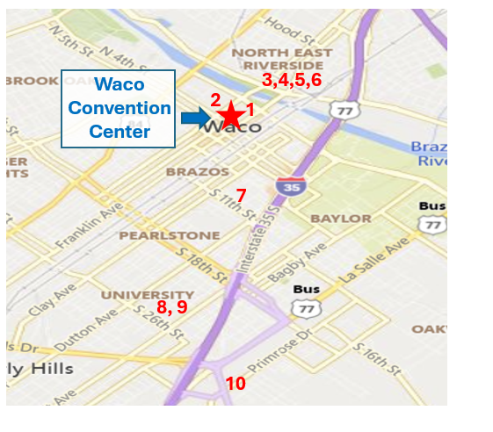
Following completion of the registration process,
you will receive an email with your registration number and link to the Hotel Reservation portal Please allow 7-10 days after your online registration
for this manual processing.
Questions may be directed to:
register.75nsdc@gmail.com
75nsdchousing@gmail.com

No airport shuttle services provided
See www.75nsdctx.com for transportation information.

You must be registered for the convention with a registration number to receive the convention rate. No self or online registration is available for the contracted rate except through the weblink, which will be provided by the convention Housing Vice-Chairman. 75nsdchousing@gmail.com

Hotel cancellations must be made 72 hours in advance to avoid a fee.

Name: ___________________________________________ __________________________________________________

More information available at www.75nsdctx.com

Revised 02/13/2026

Make your own RV & CAMPING ACCOMMODATIONS
Waco Creekside RV Resort www.wacocreeksideresort.com
1972 Leroy Pkwy, Elm Mott, TX 76640 (254) 651-3999
Call for a 15% Discount on all Cabins, RV Spots and Treehouses

Magnolia RV Resort www.magnoliarvresort.com
3096 New Dallas Hwy, Waco TX 76705 254-799-3105
Call for a 10% discount on you stay.

Say You are with the Square Dance Convention



RETURN COMPLETED FORM TO:
75NSDC
9597Jones Rd Ste #122
Houston, TX 77065
Email: register.75nsdc@gmail.com

INFORMATION FOR COMPLETING FORM

- You can complete this FORM online at www.75nsdctx.com.
- Please PRINT legibly to ensure accuracy of information.
- If you have already PRE-REGISTERED using our short form, please enter names in the appropriate space for each badge and enter $0 (zero) in subtotal by each name already registered to avoid duplicate charge.
- If not pre-registered, enter registration fee for each dancer and correctly calculate amounts in the subtotal lines, then calculate and enter the total due.
- Registration fees: Adult $80; Youth ages 5-17 by 6/27/2026- $30.00
Under 5 Free.
- Prices will increase May 1, 2026 - Adult: $95 - Youth ages 5-17- $30.00.
- Persons 3-5 circle Adult or Youth. **Only need birthday of Youth**
- Registrations are non-transferable.
- No One, Two, or Three-Day Registrations.
- A $10.00 fee per registrant will be imposed for cancellations or changes before April 30, 2026. No refunds after April 30, 2026.
- Registrations received after April 30, 2026, will receive e-mail confirmation.
- If sending by mail include credit card information, check, or money order payable in U.S. funds to 75NSDC with this form. Do not send cash.
- If registering by email, omit payment information on form. You will receive an invoice by email. (Note 3% CC payment convenience fee.)

TOURS can be purchased online at 75nsdctx.com/tours

DANCERS - PLEASE HELP US PLAN! Check all that apply.
Mainstream Plus Advanced Challenge Contra Lines Clogging Rounds Handicapable Solo
Are you participating in the Education Leadership Certificate Program?
Yes ____ No_____ Visit 75nsdctx.com for more Information

Last Name: __________________________ First Name: ________________________
Address: ______________________________________________________________
City: ________________________ State: _____ Zip: ________ Country: ___________
Phone: _____________________________ Cell Phone: ________________________
Email*: _______________________________________________________________
*E-mail address will only be shared with the NEC Check if you do not want your email shared.
First Name & Last Name for CONVENTION BADGES Subtotals
 | 1. Adult __________________________________________ | $________
 | 2. Adult __________________________________________ | $________
 | 3. Adult/Youth _____________________ ** DOB ___/___/__ | $________
 | 4. Adult/Youth _____________________ ** DOB ___/___/___ | $________
 | 5. Adult/Youth _____________________ ** DOB ___/___/___ | $________

 | Magnet for Badge (pins provided free)  75th NSDC Souvenir Program Book  ($35 after 4/30/2026) | #___  #___  #___ | @$ 2.00  @$30.00  @$35.00 | $_______  $_______  $_______
 | Round Dance Syllabus - USB Drive | #___ | @$15.00 | $________
 | Printed copy (Must be purchased by 4/30/2026) | #___ | @$15.00 | $________
 | Printed copy & USB (Must be purchased by 4/30/26) | #___ | @$25.00 | $________
 | Sew & Save Book - USB Drive or Digital Download | #___ | @$15.00 | $________
 | Hearing Assistance Device (N/C) – Refundable Deposit | #___ | @$50.00 | $________
 | Wednesday Night Special Event – Malpass Brothers
 | Dinner* & Show $55 per person Premium Seating  Dinner* & Show $45 per person Standard Seating |  | SPECIAL  SOLD | EVENT  OUT
 | *Dinner Entrée BBQ Beef____ or Grilled Chicken____
Convenience Fee for Credit Card Processing |  |  | 3.00%  TOTAL | $________  $______

PAYMENT (Complete if paying in person or by postal mail (US Funds)
Check Enclosed Cash (In Person) Credit Card Zelle
Name on Card: _____________________________________________________________
Card Type (Visa, Mastercard, AmEx, Discover): __________________________________
Card Number: _____________________________________________________________
Expiration Date: _____________________________ Security Code: __________________

Dressy casual attire allowed until 6pm. Proper dance attire is requested after 6pm for all dancers.
75th NSDC Convention badge required for entrance to all convention activities.
Shoes must be worn at all times.

75th National Square Dance Convention®
Waco Convention Center - June 24-27, 2026
100 Washington Ave, Waco, TX
WE’RE GOING TO TEXAS Y’ALL
Register online at 75nsdctx.com
Zelle your payment to 75nsdc@gmail.com

No. of past NSDC’s prior to 75th

PROGRAMMED CALLERS & DANCE LEADERS
You must update your profile yearly & online by 12/31/25 at sdconvention.com.

Name __________________________ Type: ____________________
Name __________________________ Type: ____________________
Name __________________________ Type: ____________________

HOTEL & CAMPING INFORMATION ON REVERSE

Check box if you will manage your own accommodation.

For Convention Use Only
Registration # ______________
Date Received _____________
Payment Processed _________
Check# or Ref # ____________
Revised 02/13/2026

